Research on calculation of design flood hydrographs in Liede River Basin in Guangzhou based on MIKE FLOOD
XIAO Yongjian，ZHOU Haolan，LIU Shuai
（School of Water Conservancy and Civil Engineering, South China Agricultural University, Guangzhou 510642, Guangdong, China）

Abstract：[Objective] The calculation of design flood hydrographs for urban inland rivers is crucial for the planning, design, and management of urban flood control and drainage facilities (e.g., levees, sluice gates, and pumping stations). Current engineering practices, which use the rational formula or synthetic unit hydrograph methods primarily applicable to natural watersheds, fail to reflect the impacts of urban underlying surfaces and underground pipe networks on flood hydrographs. Therefore, it is urgent to establish a rainstorm flood numerical model capable of coupling the urban surface and pipe network systems. [Methods] To this end, taking the Liede River Basin in Guangzhou as the research object, a coupled urban rainstorm flood model was constructed based on the MIKE FLOOD platform. The model was calibrated and validated using four observed flood events, achieving Nash-Sutcliffe efficiency coefficients of 0.98 and 0.93 during calibration periods, and 0.87 for both validation periods, demonstrating satisfactory simulation accuracy. The flood hydrographs under rainfall with different return periods (P = 5 a, 10 a, 50 a, and 100 a) were simulated and comparatively analyzed against traditional hydrological calculation methods. [Results] The results showed that: (1) the simulation results of the synthetic unit hydrograph method in Guangdong Province exhibited morphological characteristics of “slow rise and slow recession”, which was inconsistent with the runoff generation and concentration characteristics of high-density urbanized areas. (2) In smaller floods, the relative errors between the simulation results of the synthetic unit hydrograph method in Guangdong Province and model simulation results were relatively large. The relative errors for the 5-year and 10-year peak discharge were 33.9% and 32.9%, respectively, the relative errors for total runoff volume reached 40.5% and 36.5%, and relative errors for runoff coefficient were 37.8% and 35.4%, respectively. (3) As the return period increased from 10 years to 100 years, the relative error in flood peak decreased from 32.9% to 14.3%, the relative error in total runoff volume decreased from 36.5% to 22.3%, and the relative error in runoff coefficient decreased from 35.4% to 21.8%, indicating that the relative errors in flood indicators gradually decreased as the flood magnitude increased. [Conclusion] The findings can provide methodological references for the calculation of flood hydrographs in high-density urban areas, thereby offering technical support for the planning, design, and management of flood control and drainage facilities.
Keywords：design flood；MIKE FLOOD；synthetic unit hydrograph；rational formula；Liede River Basin；influencing factors

基于MIKE FLOOD的广州市猎德涌流域设计洪水过程线计算研究
肖永健，周浩澜，刘 帅
（华南农业大学 水利与土木工程学院，广东 广州 510642）
摘 要：【目的】城市内河设计洪水过程线计算对城市防洪排涝设施(堤防、水闸、泵站等)规划、设计和管理至关重要，当前工程实践中采用的推理公式或综合单位线主要适用于天然流域，不能反映城市下垫面和地下管网对洪水过程线的影响，亟需构建能够耦合城市地表–管网系统的暴雨洪水数值模型。【方法】为此，以广州市猎德涌流域为研究对象，基于MIKE FLOOD平台构建城市暴雨洪水耦合模型，采用4场实测洪水对模型进行率定验证，率定期与验证期的纳什效率系数分别达到了0.98、0.93、0.87、0.87，表明模型满足模拟精度要求。通过模拟不同频率暴雨重现期(P=5a、10a、50a、100a)下的洪水过程线，并与传统水文计算方法对比分析，【结果】发现：（1）广东省综合单位线法模拟结果呈现出“缓涨慢退”的形态特征，不太符合高密度城市化地区的产汇流特征。（2）在较小洪水时，广东省综合单位线法模拟结果与模型模拟结果相对误差较大，5a与10a洪峰相对误差分别达到33.9%和32.9%，径流总量相对误差分别达到40.5%和36.5%，径流系数相对误差分别达到37.8%和35.4%。（3）随着洪水重现期由10 a增至100 a，广东省综合单位线法洪峰相对误差由32.9 %降低至14.3 %，径流总量相对误差由36.5%降低至22.3%，径流系数相对误差由35.4%降至21.8%，表明随洪水级别增加，洪水指标相对误差逐步减少。【结论】可为高密度城市地区洪水过程线计算提供方法参考，进而为防洪排涝设施规划、设计和管理提供技术支撑。
关键词：设计洪水；MIKE FLOOD；综合单位线；推理公式；猎德涌流域；影响因素
中图分类号：TV122 文献标志码：A

Article history: Received 17 October 2025 ；Revised 5 January 2026；Accepted 9 January 2026；Available online
收稿日期：2025-10-17；修回日期：2026-01-05；录用日期：2025-01-09；网络出版日期：
Financial Aid：National Natural Science Foundation of China (42271011); Guangdong Provincial Water Resources and Hydropower Technology Center Research Project (JSZXWT202437)
基金项目：国家自然科学基金面上项目(42271011)；广东省水利水电技术中心科研项目(JSZXWT202437)
About the author：XIAO Yongjian（2000—），male，Master's Degree，mainly engaged in urban flood modeling. E-mail：743892739@qq.com
作者简介：肖永健（2000—），男，硕士研究生，主要从事城市洪涝模拟研究。E-mail：743892739@qq.com
Corresponding author：ZHOU Haolan（1979—），male，Associate Professor，Doctor，mainly engaged in Hydrological Modeling, 3S Technology Applications, and Water Resources Information System Development. E-mail：haolan_zhou@scau.edu.cn
通信作者：周浩澜（1979—），男，副教授，博士，主要从事水文模型、3s技术应用和水利信息系统开发研究。E-mail：haolan_zhou@scau.edu.cn

0 Introduction
Urbanization has induced significant alterations in the underlying surfaces of urban watersheds, consequently modifying natural rainfall-runoff processes^{[1-3]}. However, current practices in the planning, design, and management of urban flood control infrastructure (e.g., embankments, sluice gates, pumping stations) predominantly rely on rational formulas or synthetic unit hydrographs for flood hydrograph estimation. These methods fail to account for the impacts of urban underlying surfaces and drainage networks on flood hydrographs, thereby compromising the effectiveness of engineering projects^{[4-6]}. Hence, accurate and rational calculation of urban design flood hydrographs is of paramount practical significance for flood mitigation infrastructure ^{[7-9]}.
In recent years, researchers have begun incorporating hydro-hydrodynamic coupled models to simulate urban storm-flood processes. Some studies have demonstrated their efficacy in urban flood simulation, risk assessment, and operational decision-making.YIN et al.^{[10]}constructed a one-dimensional - two-dimensional coupled hydrological and hydrodynamic model to study the waterlogging risk in high-density built-up areas. They verified the effectiveness of the model in simulating the waterlogging process on complex underlying surfaces and identified high-risk areas. VASHIST et al.^{[11]}used a certain tool to construct a coupled rainfall - runoff and hydrodynamic model for flood simulation, proved the applicability of the model, and improved the accuracy of flood process simulation. KHATOONI et al.^{[12]}proposed a new method of a coupled model for urban waterlogging risk assessment, achieved accurate quantification of waterlogging risk, and provided technical support for waterlogging management. LU et al.^{[13]}simulated the waterlogging prevention and control effect in Tiexinqiao experimental base based on a model, quantified the waterlogging mitigation effects of different measures, and identified an efficient prevention and control plan. LUAN et al.^{[14]}carried out urban waterlogging simulation using a coupled model, and verified the model's ability to accurately simulate the urban water accumulation process. HAN et al.^{[15]}evaluated the flood risk in the upper reaches of Huangshui River through a model, identified high - risk flood areas, quantified the risk levels, and provided a basis for flood prevention and control. WANG et al.^{[16]}carried out design flood simulation for small watersheds based on hydrodynamic numerical calculation, established a corresponding simulation method, and improved the accuracy of design flood calculation. YANG et al.^{[17]}proposed an intelligent model calibration method and identified urban runoff generation patterns, improved the efficiency and accuracy of model calibration, and clarified the differences in runoff patterns on different underlying surfaces. WANG et al.^{[18]}carried out the calculation of design flood for urban inland rivers based on a hydraulic model, established relevant calculation methods, and provided data support for the design of flood control facilities.Nevertheless, existing research predominantly focuses on model development, scenario simulation, or single-event replication, with limited systematic evaluation of design flood hydrograph methodologies—particularly in high-density urban areas. Comparative studies examining discrepancies between traditional hydrological methods and coupled models remain scarce. Furthermore, there is a notable lack of research quantitatively assessing the applicability and error ranges of these approaches across different return periods within the same urban area, hindering methodological selection and standardization updates for high-density cities.
This study systematically compares traditional hydrological methods and hydro-hydrodynamic coupled models for design flood hydrograph calculation in high-density urban areas. Using Guangzhou’s Liede River Basin as a case study, we developed an urban flood coupled model based on the MIKE FLOOD platform to simulate flood hydrographs under different rainfall return periods (P= 5-, 10-, 50-, and 100-year). By contrasting results with traditional hydrological methods, we analyze the accuracy and discrepancies of conventional design flood hydrographs, evaluate their applicability in urbanized regions, and provide insights for urban flood management planning and design ^{[19-23]}.

1. Study area and data
The Liede River Basin in the Tianhe District of Guangzhou was selected as the study area. The watershed is highly urbanized^{[24-26]}, with a catchment area of 17.96 km² and a total channel length of approximately 6.5 km. The average gradient of the main channel was 2.23‰.
The data utilized in this study included a 5-meter digital elevation model (DEM) derived from LiDAR data acquired by Guangzhou Jiantong Surveying and Mapping Geographic Information Technology Co., Ltd. in 2020; pipe network distribution data obtained through field surveys; and land surface data sourced from the Resource and Environment Science and Data Center of the Chinese Academy of Sciences, with a resolution of 30 meters^{[27]}. The measured precipitation and flow data were obtained from the Guangzhou Drainage Monitoring Station. Figure 1 presents an overview of the Liede River Basin.

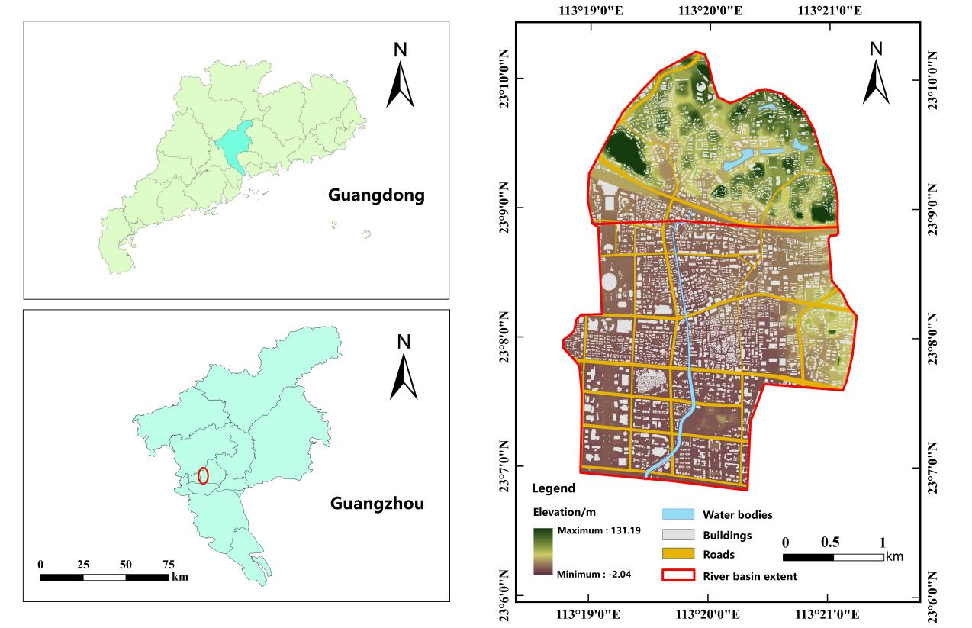
Fig.1 Overview of Liede River Basin
图1 猎德涌流域概况

2. Methods
2.1. Urban Flood Modeling
This study employed the MIKE FLOOD platform to develop an integrated urban storm-flood coupling model. By integrating surface runoff, pipe network conveyance, and channel evolution processes, the model achieves a refined multi-coupled simulation of runoff generation and collection across complex urban surfaces. The specific modeling process was as follows.
(1) One-dimensional river network model construction: The Liede River Basin contains only one main river channel, with all stormwater ultimately flowing through pipelines into Liede River. Based on the collected field data, river network, cross-section, boundary, and parameter files were created. Coupling these four files established a one-dimensional river network model for the Liede River Basin, comprising 10 cross-sections with a Manning's roughness coefficient of 0.019.
(2) Two-dimensional surface runoff model construction: The core steps for building the MIKE 21 surface runoff model involved terrain processing and grid partitioning to establish the surface elevation model, followed by setting the boundary and initial conditions. A 2D surface model was created using a 5m-resolution DEM. Structures were elevated by 5m to block flow, while road elevations were lowered by 0.15m to guide floodwater. The surface Manning coefficient was set to 0.031; with the initial water depth and flow set to zero; and the initial velocity maintained at zero. The simulation duration was aligned with the rainfall boundary conditions in MIKE URBAN, using a time step of 0.5 s.
(3) One-dimensional pipe network model construction: MIKE URBAN pipe network model^{[28]} Primarily imported data for 591 stormwater inlets, 18 outfalls, and pipe networks. Diameter values were assigned to nodes, catchment boundaries were manually imported, and automatic delineation was performed. Assigned catchment parameters based on relevant research^{[29]} The Mouse T-A model, suitable for highly urbanized areas, was employed to calculate imperviousness rates and hydrological parameters. Imperviousness rates were set at 80% for built-up areas, 90% for roads, and 20% for green space. The average surface flow velocity was 0.3 m/s, runoff reduction coefficient was 0.9, and Manning's roughness coefficient for pipes was 0.012.
(4) Model Coupling: The established MIKE 11, MIKE 21, and MIKE URBAN models were coupled via MIKE FLOOD. This approach simultaneously depicts the hydrodynamics within the pipe network and visually displays surface runoff during heavy rainfall and post-storm drainage processes. A total of 609 coupling points were set up, including 18 URBAN-MIKE 11 coupling points and 591 URBAN-MIKE 21 coupling points. The flood process line at the watershed outlet was obtained using MIKE 11. The model coupling is illustrated in Figure 2.
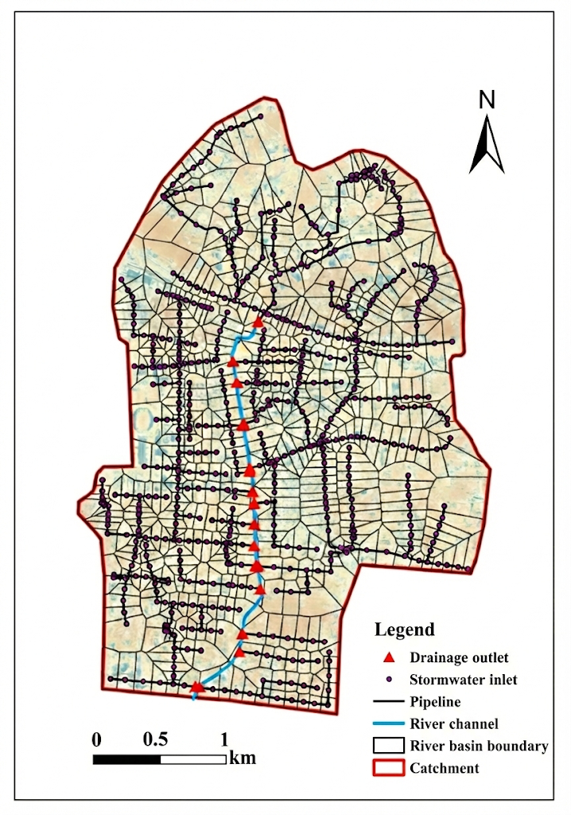
Fig.2 MIKE FLOOD model coupling
图2 MIKE FLOOD模型耦合
2.2. Model Validation
This study utilized four observed rainfall events from the Liede River Basin between 2010 and 2014. Validation was conducted using three metrics: Nash efficiency coefficient ($NSE$), Peak absolute error (PAE), and Agreement index ($IA$).
The Nash–Sutcliffe efficiency coefficient ($NSE$)^{[30]} was defined as
$NSE=1−\frac{\sum_{t=1}^{T}{{\left(Q_{o}^{t}−Q_{m}^{t}\right)}^{2}}}{\sum_{t=1}^{T}{{\left(Q_{o}^{t}−\overline{Q_{o}}\right)}^{2}}}$ (1)
In Eq. (1),$Q_{o}^{t}$ represents the observed value at time t（m³·s⁻¹）;$Q_{m}^{t}$ represents the simulated value at time t（m³·s⁻¹）;$\overline{Q_{o}}$ represents the observed mean value（m³·s⁻¹）.
$NSE$ The range of values was from negative infinity to 1. The closer $NSE$ is to 1, the better is the simulation performance of the model. When $NSE$ approaches 0, it indicates that the simulation results are close to the average level of the observed values, but the process simulation error is significant. The larger the $NSE$ value, the better the model performance.
The Agreement index ($IA$)^{[31]} was defined as
$IA=1−\frac{\sum_{t=1}^{T}{{\left(Q_{m}^{t}−Q_{o}^{t}\right)}^{2}}}{\sum_{t=1}^{T}{{\left(\left|Q_{m}^{t}−\overline{Q_{o}}\right|+\left|Q_{0}^{t}−\overline{Q_{o}}\right|\right)}^{2}}}$ (2)
In Eq. (2),$Q_{o}^{t}$ represents the observed value at time t（m³·s⁻¹）;$Q_{m}^{t}$ represents the simulated value at time t（m³·s⁻¹）;$\overline{Q_{o}}$ represents the observed mean value（m³·s⁻¹）.
$IA$ The value ranges from negative infinity to 1. When $IA$ approaches 1, it indicates that the trends of the observed and simulated values are similar, and the model has high credibility.
As shown in Figure 3 and Table 1, after calibrating the model parameters using the rainfall events of 20100507 and 20100514, the Nash efficiency coefficients for each event were calculated as 0.981 and 0.929, respectively. The peak absolute errors were 4.12% and 4.25%, and the agreement indices were 0.995 and 0.981, respectively. For model validation using the 20130830 and 20140511 rainfall events, the Nash efficiency coefficients were 0.874 and 0.867, respectively; the peak absolute errors were 8.58% and 7.6%, respectively; and the agreement indices were 0.964 and 0.965, respectively. These results met the hydrological forecasting standards. This indicates the model's suitability for calculating urban flood process lines in the study area.
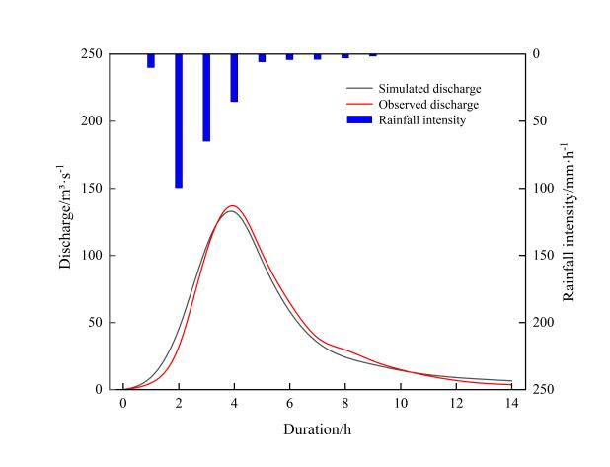 | 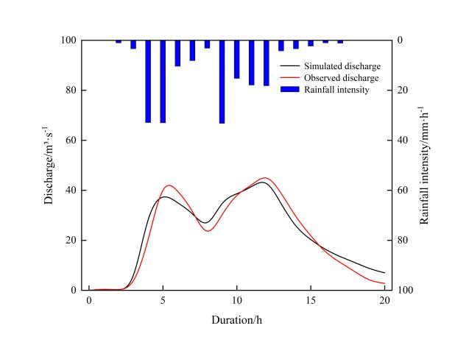
（a）Rainfall event of 20100507 | （b）Rainfall event of 20100514
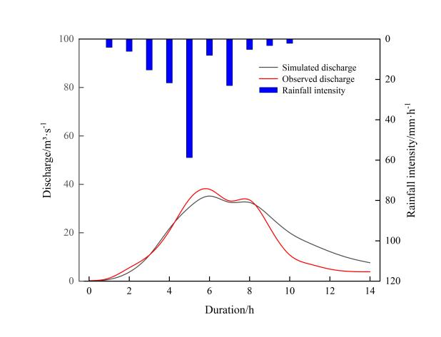 | 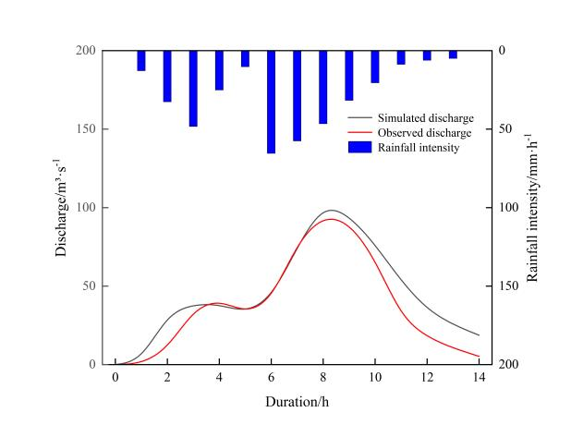
（c）Rainfall event of 20130830 | （d）Rainfall event of 20140511
Fig. 3 Rainfall-runoff hydrographs for calibration and validation periods
图3 率定期与验证期降雨径流过程线

Table 1 Comparison of model calibration and validation results
表1模型率定和验证成果对比
 | Rainfall event | $$NSE$$ | $PAE$/% | $$IA$$
Calibration period | 20100507 | 0.981 | 4.12 | 0.995
Calibration period | 20100514 | 0.929 | 4.25 | 0.981
Validation period | 20130830 | 0.874 | 8.58 | 0.964
Validation period | 20140511 | 0.867 | 7.60 | 0.965

3. Results
This study calculated 24-hour design rainfall events for 5, 10, 50, and 100-year return periods based on the Guangdong Province Heavy Rainfall Runoff Calculation Chart. Table 2 presents the design peak discharge results derived from the two traditional methods. The results indicate that the relative error in the design peak discharge calculated by both methods remains within 20%, meeting the computational requirements. Following the "Guangdong Province Manual for Using Torrential Rainfall Runoff Calculation Charts," the comprehensive unit-line method of Guangdong Province was adopted after reasonably coordinating the comprehensive unit-line and inference formula methods to achieve comparable design peak discharge values.
In the comparative analysis, the results from the coupled comprehensive unit hydrograph method and MIKE FLOOD model served as the benchmark. By quantitatively comparing the flood hydrographs from both methods, their differences and underlying causes were analyzed. Figure 4 presents a comparative analysis of the flood hydrographs calculated using the Guangdong Comprehensive Unit Hydrograph Method and the urban flood model. Table 3 shows a comparison of the peak discharge, Table 4 presents a comparison of the total runoff, and Table 5 displays a comparison of the runoff coefficients.

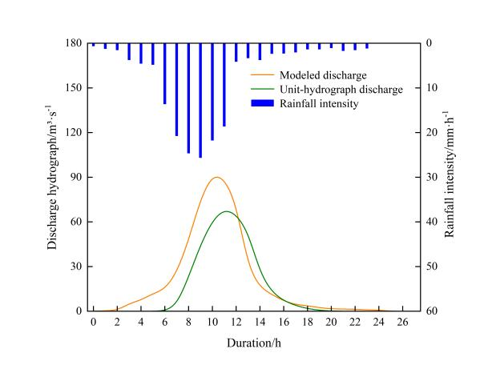 | 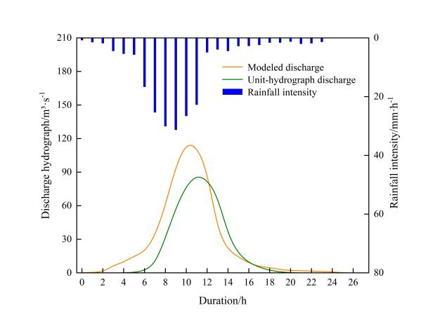
（a）5-year return period | （b）10-year return period
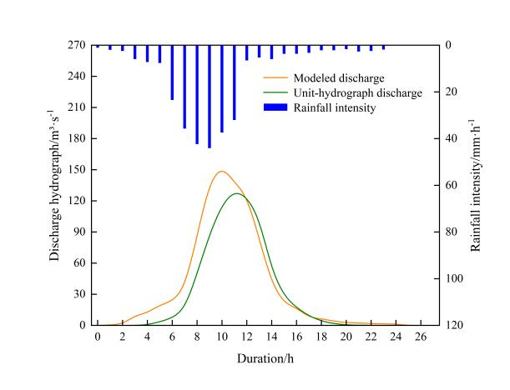 | 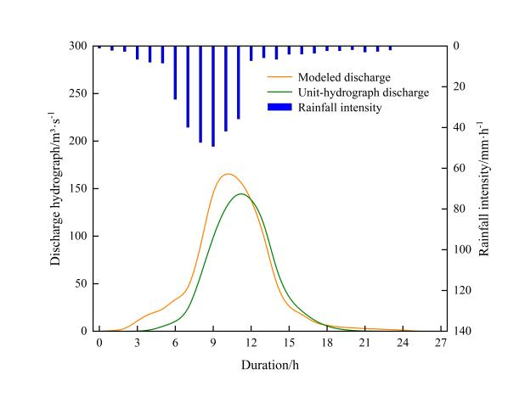
（c）50-year return period | （d）100-year return period
Fig.4 Comparison of flood hydrographs under rainfall with different return periods
图4 不同重现期降雨下的洪水过程线对比

Table 2 Comparison of design peak discharge calculation results between synthetic unit hydrograph method and rational formula method
表2 综合单位线法和推理公式法设计洪峰计算成果对比
Design frequency | Synthetic unit hydrograph method Qm  /m³·s⁻¹ | Rational formula method Qm  /m³·s⁻¹ | Relative error /%
P=20% | 68.64 | 64.42 | 6.55
P=10% | 87.53 | 87.71 | 0.21
P=2% | 129.88 | 136.33 | 4.97
P=1% | 147.50 | 151.83 | 2.94

Table 3 Comparison of peak discharge
表3 洪峰流量对比
Return period | Unit line peak  /m³·s⁻¹ | MIKE model peak  /m³·s⁻¹ | Relative error/%
P=5a | 68.64 | 91.89 | +33.9
P=10a | 87.53 | 116.32 | +32.9
P=50a | 129.88 | 153.61 | +18.3
P=100a | 147.50 | 168.65 | +14.3

Table 4 Comparison of total runoff volume
表4 径流总量对比
Recurrence interval | Unit line total runoff volume  /m³ | MIKE model runoff volume  /m³ | Relative error/%
P=5a | 1.34×10⁶ | 1.883×10⁶ | +40.5
P=10a | 1.746×10⁶ | 2.384×10⁶ | +36.5
P=50a | 2.709×10⁶ | 3.358×10⁶ | +24.0
P=100a | 3.121×10⁶ | 3.818×10⁶ | +22.3

Table 5 Comparison of runoff coefficients
表5 径流系数对比
Recurrence interval | Unit line runoff coefficient | MIKE model runoff coefficient | Relative error/%
P=5a | 0.45 | 0.62 | +37.8
P=10a | 0.48 | 0.65 | +35.4
P=50a | 0.54 | 0.66 | +22.2
P=100a | 0.55 | 0.67 | +21.8

4. Discussion
4.1. Comparison of Simulation Results
Figure 4 and Tables 3, 4, and 5 systematically reveal the differences in flood process curves and the patterns of deviation in peak discharge, total runoff, and runoff coefficient between the comprehensive unit-line method and the MIKE FLOOD model for four recurrence intervals (P=5a, 10a, 50a, 100a) in the Liede River Basin, Guangdong Province. Overall, the unit-curve method generally produced flood process curves characterized by a "relatively gentler peak rise, slower drawdown, and slightly lower peak discharge," which poorly aligned with the runoff characteristics typical of urbanized areas. However, as the recurrence interval increased, the discrepancies in the peak discharge, total runoff volume, and runoff coefficient between the two methods gradually diminished, and the steepness of the process lines tended to converge. This indicates that the unit-curve method exhibits reduced errors under high-intensity rainfall scenarios and retains some applicability. The following sections provide an in-depth comparative analysis focusing on the process line morphology and multidimensional indicators.

4.1.1. Process Line Morphology
In urban areas, extensive natural vegetation and farmland have been replaced by streets, factories, residential buildings, and other structures, leading to significant changes in the water retention and permeability of the surface. Following rainfall in urban areas, the volume of water retained in depressions and lost through infiltration is minimal. Coupled with the comprehensive urban road network, ditches, and sewer systems, the natural storage capacity within urban catchments is diminished. This increases the hydraulic efficiency of runoff collection and markedly elevates runoff coefficient. The combined effects resulted in increased total runoff volume and peak discharge, an earlier onset of peak flow, and a steeper and narrower flood hydrograph. Traditional integrated unit lines are primarily suitable for natural watersheds. Consequently, compared with urban flood models, the unit line method yields reduced peak discharge, total runoff volume, and runoff coefficient to varying degrees. The process curve generated by the unit line method also exhibits a markedly flattened rise phase and a prolonged drawdown phase, presenting a "slow rise and slow drawdown" characteristic that poorly aligns with urban runoff generation and collection patterns.

4.1.2. Multidimensional Indicator Analysis
Comparative results for peak discharge, total runoff volume, and runoff coefficient (Tables 3–5) reveal systematic biases in traditional urban flood calculation methods. Regarding peak discharge, the Guangdong Province comprehensive unit-line method consistently underestimates values across all return periods, with discrepancies ranging from 14.3% to 33.9%. This deviation stems from the high proportion of impervious surfaces in urbanized areas, which increase runoff coefficients and accelerate runoff velocity. By dividing the catchment into multiple sub-basins and assigning corresponding runoff coefficients to different land surfaces, the model aligns with the urban runoff generation and flow mechanisms. In contrast, the unit root method employs a uniform imperviousness rate, failing to simulate the amplification effect of impervious areas on peak flows, resulting in a systematic underestimation.
Analysis of runoff-related metrics revealed that under all storm recurrence intervals, the unit-line method consistently underestimates both total runoff volume and runoff coefficients compared with the coupled model, with discrepancies ranging from 21.8% to 40.5%. This discrepancy likely stems from the unit-line method's use of a fixed initial loss parameter combined with a single infiltration rate, which overestimates the infiltration capacity in urbanized areas.
Notably, the three parameter discrepancies exhibited systematic variation with storm intensity: as return periods extended from 5 to 100 years, peak flow errors declined from 33.9% to 14.3%, total runoff volume errors decreased from 40.5% to 22.3%, and runoff coefficient errors narrowed from 37.8% to 21.8%. This discrepancy pattern can be attributed to the following mechanisms: during low-intensity storms (P=5~10 years), sewer network regulation and permeable surface infiltration dominated hydrological processes, where conventional methods overestimated initial abstraction under sub-threshold rainfall intensities, yielding lower runoff estimates. The inability of conventional approaches to account for sewer storage and heterogeneous underlying surfaces amplified errors under mild precipitation. Conversely, during high-intensity events (P=50-100 years), rapid impervious surface runoff and depression storage saturation became predominant, with limited influence from drainage systems and underlying surfaces, consequently reducing methodological discrepancies.
Beyond peak discharge, flood volume, and runoff coefficient, time-to-peak (Tp) and the skewness coefficient (Cs) are critical metrics for characterizing the flashiness and early-warning capability of urban flooding. Table 6 summarizes the differences in Tp and Cs between the MIKE model and the synthetic unit hydrograph (SUH) method across four return periods. On average, the SUH-derived Tp lags behind that of the MIKE model by 1.8 hours (5-year return period) to 0.6 hours (100-year return period), while the corresponding Cs values are 0.31 to 0.22 lower. This indicates that the conventional SUH approach not only underestimates peak flows but also delays the timing of peak occurrence, resulting in an additional 0.5–2 hour reduction in early-warning lead time. As storm severity increases, faster conduit convergence and the two-way interaction between surface runoff and ponding tend to reduce the Tp discrepancy; however, Cs remains substantially lower, demonstrating that the characteristic “sharp-and-thin” shape of urban hydrographs cannot be adequately replicated through parameter calibration alone.

Table 6 Comparison of time-to-peak and skewness coefficients
表6 峰现时间与偏态系数对比表
Recurrence interval | Tp of unit hydrograph method/h | MIKE Tp  /h | ΔTp /h | Cs of unit hydrograph method | MIKE Cs | ΔCs
P=5a | 11.4 | 9.6 | -1.8 | 0.97 | 1.28 | -0.31
P=10a | 11.2 | 9.8 | -1.4 | 1.02 | 1.31 | -0.29
P=50a | 10.8 | 10.0 | -0.8 | 1.10 | 1.36 | -0.26
P=100a | 10.7 | 10.1 | -0.6 | 1.15 | 1.37 | -0.22

5. Conclusions
Using the Liede River Basin in Guangzhou as a case study, this study systematically compared the differences between the integrated unit-line method and MIKE FLOOD coupled model in calculating urban design flood hydrographs. The preliminary conclusions are as follows.
（1）The SUH method exhibited hydrographs with "gentle rising limb and slow recession" characteristics, deviating from rapid runoff processes in hyper-urbanized areas. Significant errors occurred in minor floods (5-10 year return periods): peak flow errors reached 33.9%-32.9%, total runoff errors 40.5%-36.5%, runoff coefficient errors 37.8%-35.4%, with peak time lags (ΔTp) of 1.8-1.4 hours. Although errors decreased monotonically with increasing return periods (5→100 years) - peak flow errors reduced to 14.3%, total runoff to 22.3%, and ΔTp to 0.6 hours - the persistently lower skewness coefficients (Cs) revealed inherent limitations in simulating urban hydrograph's "peak-sharp" features.
（2）The MIKE FLOOD model, through real-time surface-pipe-river coupling, effectively simulated complex urban runoff processes. It quantified impervious surface-induced runoff amplification mechanisms, achieving Nash-Sutcliffe coefficients of 0.87-0.98, agreement indices of 0.964-0.995, and peak errors <10% during calibration/validation. This confirms its reliability for flood risk assessment in high-impermeability urban areas.
References
[1] MA Y, CUI Y T, TAN H G, et al. Case study: Diagnosing China’s prevailing urban flooding: Causes, challenges, and solutions[J]. Journal of Flood Risk Management, 2022, 15(3): e12822.
[2] FU Y., JIANG X, LIU Y, et al. Research progress on integrated urban water management[J].Journal of University of Jinan, 2023, 37:39-47.
[3] YAN Q, DU E, ZHENG C. Urban flood emergency evacuation simulation and its efficiency-fairness tradeoff analysis[J].Advances in Water Science, 2023, 34:409-417.
[4] HUANG G, CHEN W, YU H. Construction and evaluation of an integrated hydrological and hydrodynamics urban flood model[J]. Advances in Water Science, 2021, 32: 334-344.
[5] CAO B, BAI Y, WANG X, et al. Simulation analysis of flood process in Kushan River, Xinjiang[J]. China Rural Water and Hydropower, 2024（2）: 23-30.
[6] PAN X, LI Q, CHEN J, et al. Urban area watershed flood simulation with hydraulic model: A case study of Qinghe river in Beijing[J]. Journal of Hydroelectric Engineering, 2015, 34: 71-80.
[7] PENG C, HONG L, LU L. River design flood parameter selection based on synthetic unit hydrograph. Eng[J]. Engineering Journal of Wuhan University, 2012, 45: 590-593.
[8] SUN W, MEI G, WANG S, et al. Comparative analysis of inference formula method and instantaneous unit hydrograph method in flood calculation of tailings pond[J]. Nonferrous Metals, 2022, 12: 122-127.
[9] MA X, LIN K, GUO W, et al. Evaluation and revision of synthetic unit hydrograph of guangdong under the background of urbanization[J]. China Rural Water and Hydropower, 2024（1）: 142-149.
[10] YIN W H, LIU J, FENG H T, et al. Study of flooding hazards in highly urbanized area based on a coupled one- and two-dimensional hydrological-hydrodynamic model[J]. Desalination and Water Treatment, 2025, 321: 100933.
[11] VASHIST K, SINGH K K. Coupled rainfall-runoff and hydrodynamic modeling using MIKE + for flood simulation[J]. Iranian Journal of Science and Technology, Transactions of Civil Engineering, 2025, 49(3): 3017-3026.
[12] KHATOONI K, HOOSHYARIPOR F, MALEKMOHAMMADI B, et al. A new approach for urban flood risk assessment using coupled SWMM–HEC-RAS-2D model[J]. Journal of Environmental Management, 2025, 374: 123849.
[13]LU H, ZOU Y, SUN J, et al. Simulation of waterlogging control effect in Tiexinqiao experimental base based on SWMM[J]. Water Resources Protection，2020（36）: 58-65.
[14]LUAN Z, JIN Q, ZHAO S, et al. Simulation of urban waterlogging based on MIKE FLOOD coupling model[J]. Water Resources Protection，2021（37）: 81-88.
[15]HAN L, GAI Y, LIU Y, et al. Risk assessment of floods in the upper reaches of huangshui river based on MIKE FLOOD coupled model[J]. China Rural Water and Hydropower，2017, 07: 161-165.
[16]WANG P, CHENG L, PU B, et al. Research on design flood simulation of small watershed based on hydrodynamic numerical calculation[J]. Hydropower and Pumped Storage, 2024, 10: 14-19.
[17] YANG Z X, LIU J H, FENG Y C, et al. An intelligent SWMM calibration method and identification of urban runoff generation patterns[J]. Frontiers in Environmental Science, 2025, 13: 1582306.
[18]WANG J S, ZHANG Y, KUANG M Y. Calculation of flood hydrograph for urban river based on hydraulic model[J]. China Water Wastewater，2016(32): 13-17.
[19] XU N, SUN Y J, SUN Y Z, et al. Prediction of flood processes based on general unit hydrograph[J]. Water, 2025, 17(2): 258.
[20] SHEN Y X, XU Z M, ZHOU Q, et al. A direct two-way coupling of the hydrologic and 1D-2D hydrodynamic models for watershed flood simulation[J]. Journal of Hydrology, 2024, 639: 131606.
[21] WANG K, CHEN J, HU H, et al. Urban waterlogging simulation and disaster risk analysis using InfoWorks integrated catchment management: A case study from the Yushan Lake area of Ma’anshan City in China[J]. Water, 2024, 16(23): 3383.
[22] YUN H, KANG J. Evaluating the stormwater runoff reduction effect of green infrastructure using a SWMM-based LSTM model: A case study of Seocho-gu, Seoul[J]. Urban Climate, 2025, 64: 102692.
[23] LI Y B, LI H X, HAN Y H, et al. Impact analysis of urban super-standard flood disasters based on MIKE+[J]. Natural Hazards, 2025, 121(13): 15949-15963.
[24]WANG S, ZHANG S, XIONG Y, et al.The hydrodynamic effects of river-lake system connectivity on urban river ecological restoration: A case study of Liede Creek[J]. People's Pearl River, 2025, 46(1): 1-8.
[25]YUAN J, CHEN W, ZHAO T, et al. Dimensionality reduction simulation technology for stormwater drainage networks in high-density urban areas focusing on computational efficiency[J]. Water Resources Protection, 2025, 40(6): 69-77.
[26]ZHAO L, MO Y, DU Z, et al. Research on the simulation model of urban drainage and flood control under the optimization control of gate based on SWMM：Taking Liede River basin as an example[J]. China Rural Water and Hydropower, 2019（9）: 171-176.
[27]ZHONG J, HE J, DENG Z, et al. The impacts of dense buildings on urban flood simulation[J]. China Rural Water and Hydropower, 2023（8）: 32-40.
[28] THUY KIM DOAN P, CUONG LE X, THAO LE V, et al. Evaluating the impacts of an improved sewer system on city flood inundations using MIKE Urban Model[J]. Vietnam Journal of Earth Sciences, 2023, 45(4): 438-455.
[29] SUN X C, XIONG L H, ZHOU M, et al. Research on waterlogging in typical urban area of Wuhan City based on MIKE URBAN model: II: Analysis of drainage capacity of pipeline network[J]. Journal of Water Resources Research, 2021, 10(5): 470-479.
[30] NASH J E, SUTCLIFFE J V. River flow forecasting through conceptual models part I: A discussion of principles[J]. Journal of Hydrology, 1970, 10(3): 282-290.
[31] WILLMOTT C J. On the validation of models[J]. Physical Geography, 1981, 2(2): 184-194.

